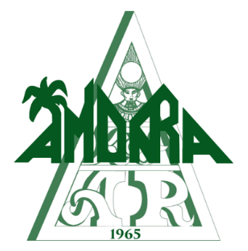
Ball Captain 54
John East
(504) 717-3691
porro52@yahoo.com

President
Jeremy Weinberg
(330) 509-0249
zwink74@gmail.com

2018 Sponsorship for the Mystic Krewe of Amon-Ra

Platinum Sponsorship $2,000
Acknowledgement at all Krewe of Amon-Ra functions
Company Logo will be prominently displayed at all Krewe of Amon-Ra Events
Full Page Black & White Ad in a Mid-Year function
4 Complimentary Tickets to all Amon-Ra functions
5 Complimentary Tickets to our Mid-Year function
Full Page Color Ad in Amon-Ra’s 54th Ball Program
Table (10 tickets) to Amon-Ra’s 54th Ball
Link Exchange on the Krewe of Amon-Ra’s website and Facebook Page
Gold Sponsorship $1,000
Acknowledgement at all Krewe of Amon-Ra functions
Company Logo will be prominently displayed at all Krewe of Amon-Ra Events
Half Page Black & White Ad in a Mid-Year function
2 Complimentary Tickets to all Amon-Ra functions
3 Complimentary Tickets to our Mid-Year function
Half Page Color Ad in Amon-Ra’s 54th Ball Program
5 Complimentary tickets to Amon-Ra’s 54th Ball
Link Exchange on the Krewe of Amon-Ra’s website and Facebook Page
Silver Sponsorship $500
Acknowledgement at all Krewe of Amon-Ra functions
Company Logo will be prominently displayed at all Krewe of Amon-Ra Events
1 Complimentary Tickets to all Amon-Ra functions
2 Complimentary Tickets to our Mid-Year function
Half Page Black & White Ad in Amon-Ra’s 54th Ball Program
2 Complimentary tickets to Amon-Ra’s 54th Ball
Link Exchange on the Krewe of Amon-Ra’s website and Facebook Page
Bronze Sponsorship $250
Acknowledgement at all Krewe of Amon-Ra functions
Company Logo will be prominently displayed at all Krewe of Amon-Ra Events
1 Complimentary Tickets to all Amon-Ra functions
Half Page Black & White Ad in Amon-Ra’s 54th Ball Program
Link Exchange on the Krewe of Amon-Ra’s website and Facebook Page
Patron Sponsorship $100
Company Logo will be prominently displayed at all Krewe of Amon-Ra Events
Name Listed n Amon-Ra’s 54th Ball Program
Link Exchange on the Krewe of Amon-Ra’s website and Facebook Page

2018 Sponsorship for the Mystic Krewe of Amon-Ra

Company/Sponsorship Organization
Organization’s Anniversary/Birthdate
Sponsorship Level
Contact Name
Contact Email Contact Phone
Street Address City/State/Zip

Sponsorship can be obtained at any time before the Ball. To be included in the Mid-Year Function program, the deadline for payment is September 1, 2018. To be included in the Ball program, the deadline for payment is December 1, 2018.

54th Annual Ball – February 9th, 2019

Thank you for supporting the Mystic Krewe of Amon-Ra!

