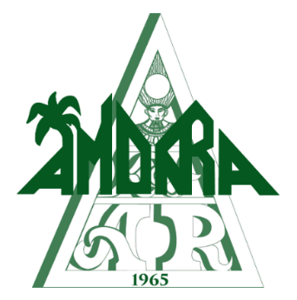
Ball Captain 54
John East
(504) 717-3691
porro52@yahoo.com

Ball Lieutenant
Matt Easley
(504) 495-8970
matteasley@aol.com

Ball Program Ads for 54th Annual Amon-Ra Ball

Center Spread $700
Quantity Available: 1
16” (w) x 10” (h)
Advertise your entity here with a brilliant two-page center ad in our ball program. Buy it before it’s gone.
Full Page (Inside Cover) $300
Quantity Available: 1
8” (w) x 10” (h)
Advertise your entity here with a brilliant full-page ad in our ball program. Buy it before it’s gone.
Full Page (Inside Back Cover) $300
Quantity Available: 1
8” (w) x 10” (h)
Advertise your entity here with a brilliant full-page ad in our ball program. Buy it before it’s gone.
Full Page (Back Cover) $300
Quantity Available: 1
8” (w) x 10” (h)
Advertise your entity here with a brilliant full-page ad in our ball program. Buy it before it’s gone.
Full Page $250 (Color) or $150 (B&W)
Quantity Available: 100
8” (w) x 10” (h)
Advertise your entity here with a brilliant full-page ad in our ball program. Buy it before it’s gone.
Half Page $175 (Color) or $90 (B&W)
Quantity Available: 100
8” (w) x 5.25” (h)
Advertise your entity here with a brilliant full-page ad in our ball program. Buy it before it’s gone.

Ad Format

 | Format
Requirements | We ask that all artwork be 300 dpi resolution in one of the following formats: .jpeg, .png, .tiff, or .pdf. If you have other formats of .eps or .svg, please reach out to Jeremy Weinberg for help.

Ball Program Ad Contact Information

Company/Sponsor Organization
Organization’s Anniversary/Birthdate
Contact Name
Contact Email Contact Phone
Street Address City/State/Zip

Ball Program Ads can be purchased through December 31, 2018. Completed forms should be emailed to KreweofAmonRa@outlook.com. Ads can be purchased by anyone: it can be an advertisement for a business/service, congratulations to the Krewe of Amon-Ra, or a tribute to anyone.

Ad Payment Options

 | Purchaser Information
Cash | Arrange to meet with a Board Member to receive the payment. Ad information can be emailed ahead of time.
Check | Arrange to meet with a Board Member to receive the payment or mail to our P.O. Box. Ad information can be emailed ahead of time.
Credit Card | Contact Ron Issler so that he can arrange the payment using our merchant account.

54th Annual Ball – February 9th, 2019

Thank you for supporting the Mystic Krewe of Amon-Ra!

